A picture containing clipart

Description generated with very high confidence

Azure 103 Module 4

Hands On - 13

Azure Certification Training

[**support@intellipaat.com**](mailto:support@intellipaat.com)

**+91-7022374614**

**US: 1-800-216-8930(Toll Free)**

**Azure 103 Module 4 , Hands On – 13**

**Add Security rule to NSG**

**Step 1:** Open the VM Attached with the subnet on which security group will be applied.

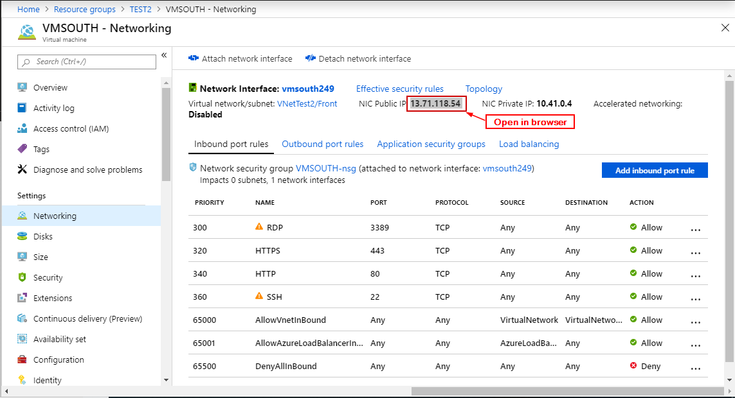

**Step 2:** Try to open its public IP (‘NIC Public IP’) in browser (Notice you can’t access it yet).

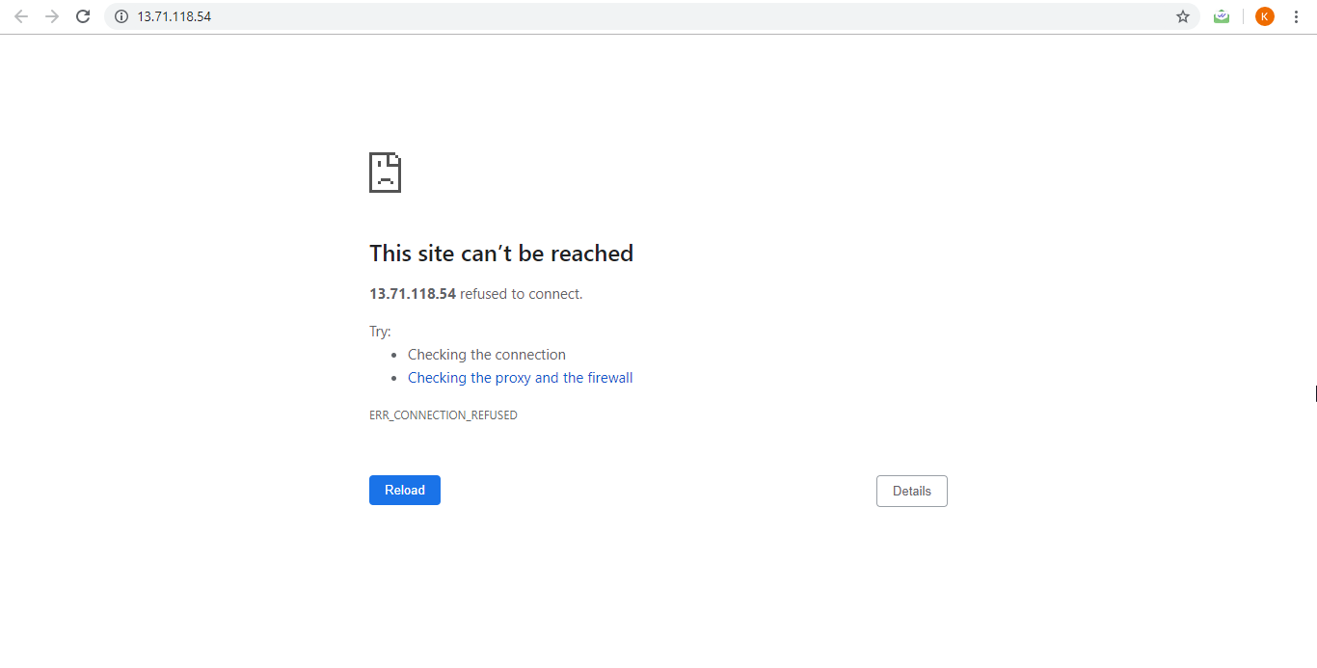

**Step 3:** Open the Network Security Group.

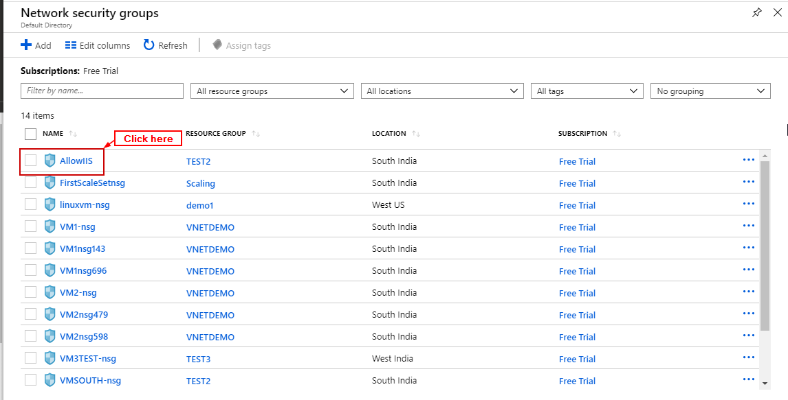

**Step 4:** Click on ’Inbound security rules’.

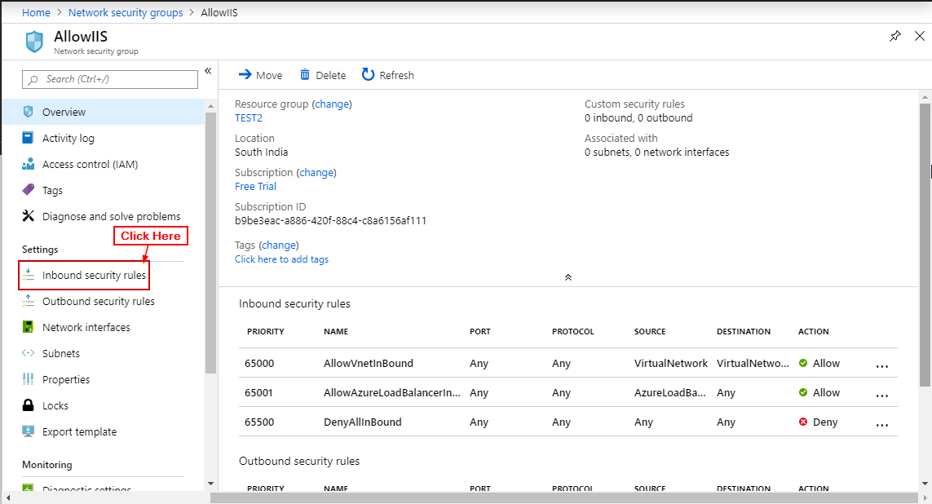

**Step 5:** Click on ‘+ Add’.

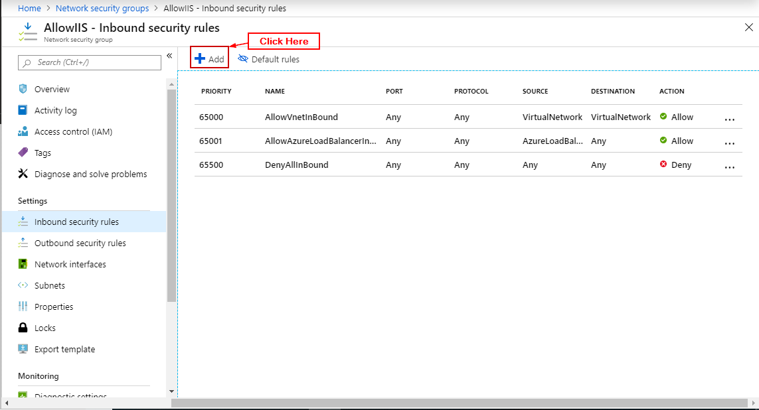

**Step 6:** Enter Details and click “Add”.

